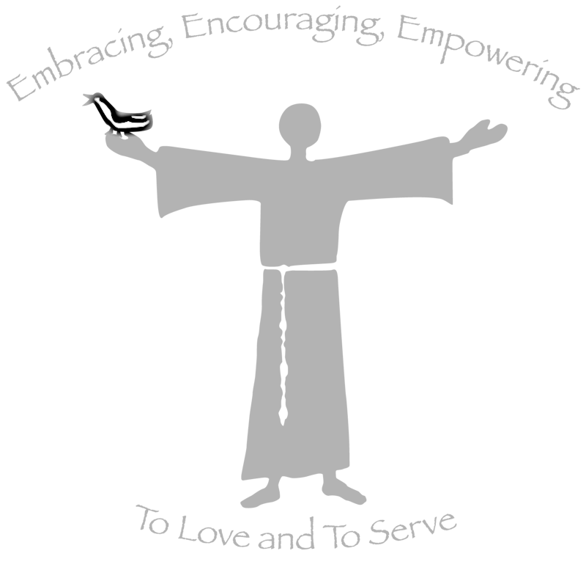

St. Francis by the Lake

Diocese of West Texas

Annual Parish Meeting

January 29, 2017

Table of Contents

Annual Parish Meeting Minutes for 2016 page 3

Acolyte Ministry page 4

Adult Education page 4

Altar Guild page 4-5

Brotherhood of St. Francis page 5

Vacation Bible School page 5-6

Choir page 6

Christian Education for Children and Youth page 6

Building Committee *(includes pictures of layout of new building)* page 6-12

Church Periodical Club page 13

Columbarium page 13

Community of Hope page 13-14

Daughters of the King page 15

Episcopal Church Women (ECW) page 15-17

Evangelism and Newcomers page 17

F.E.A.S.T. (Friends Eating and Sharing Together) page 17-18

Flower Guild page 18

*Good News* page 18-19

*The* *Franciscan* page 19

Manos de Dios Honduras Ministry page 19-21

Ministers of Love *(take them a meal)* page 21-22

Lay Eucharistic Visitors page 22

Hospitality page 22-23

Ushers and Greeters page 23-24

Landscape page 24

Lay Eucharistic Ministers and Lectors page 24

Memorials page 24-25

Prayer Shawl Ministry page 25

Outreach Activities 2016 page 25

Stewardship page 25-26

Veterinary & Public Health Mission to Diocese of SE Mexico page 26-27

St. Francis by the Lake Website page 27

United Thank Offering (UTO) page 27-28

Treasurer’s Report page 28

Junior Warden Report page 29

Senior Warden Report page 29-31

Rector’s Report page 31

Financials page 32-38

**St. Francis by the Lake**

**The Minutes of The Annual Parish Meeting – January 24, 2016**

The Annual Meeting opened in prayer.

Fr. David went over the Canons, stating that you have to be at least 16 years old, give to the church, and you have attended St. Francis at least three times within the year. Fr. David welcomed the new vestry members: Don Stackhouse, Linda Bosenbark, and Brenda Smith. The 2016 Council alternates: Valerie Kirk, Libby Templeton, and Brenda Amos; and delegates: Bob Amos, Brenda Klaftenegger, and Don Stackhouse; were elected at the Dec. 13, 2015 meeting.

Dale Calvert moved and Tom Meyer seconded to accept the minutes of the previous year. Motion was approved.

Bob Amos, Sr. Warden, talked in a taped video to the congregation as he is flying out to China. He stated that St. Francis has done a lot of work in a lot of areas – parking lot, new entrance, new signs, new sound system in the church, created a new Building Committee, and diocesan feedback from the Sensing Sessions. Bob shared is gratitude for the vestry which is close family, like what he feels for St. Francis.

Lynda Leadford, Treasurer, presented the Financial Report restating her “WOW” of last year! She stated that the Operating Funds are positive, and the end of the 2015 Financials’ results has left her speechless. The beginning of 2015 with a deficit budget of $22,000, and finished the year in the black by $18,000. She stated that St. Francis has participated in so many ministries. “Thank you, all of you who have supported our church.” Lynda mentioned that Micheline Ellas is taking her place at the end of January. Libby Templeton personally thanked Lynda Leadford for being so faithful in her ministry as St. Francis’ Treasurer.

Fr. David stated that we are no longer satisfied with the status quo. The Building Committee has done a fantastic job! The Vestry put together a Capital Stewardship campaign with the help from Ted and Nancy. Fr. David stated that the vestry was able to move forward in so many ways.

**1.** Brenda Klaftenegger, not knowing a lot about asphalt, thanked her husband, Marcel, for helping with the parking lot project. Brenda stated that she received nine bids and decided to go with Luke’s Asphalt Paving in Canyon Lake.

**2.** Jeanne Slupik stated that she and Jay Hillin took bids for new signage and the landscape. They decided to use Upright Landscaping in Canyon Lake, and Ken Osborne made the new signage. The tree line on Spring Mountain Drive was trimmed.

**3.** Maury Meyer, Building Committee Chair, thanked the Building Committee for all their work. She was grateful with the plans that will meet our needs, but be affordable to our congregation.

Diocese Feasibility – Capital Campaign Division: Forty-one families were interviewed by Ted Burkhart and Nancy Stinson, and eight replied online. St. Francis is not in a *growth mode*. The 2/3 participants are involved in four or more ministries. The strength of St. Francis is its people. The weakness of St. Francis is its lack of youth.

Brad Mount talked about “moving forward.” Fr. David motivated Brad to join the vestry. Brad stated that “Fr. David has a way of pushing people out of their comfort zone, and try something new we might not thought we could do. We serve, we do, and we move forward.”

Betty Morris moved and Dale Jones seconded motion to approve the Annual Parish Report. Motion was approved.

Julie Chalk and Tricia Jones spoke about Community of Hope (COH,) a new ministry at St. Francis. The two talked about what this ministry means to them. Bette Wehner thanked COH for being there for her and Sterling.

Fr. David thanked Dale Jones for his amazing gift as Junior Warden. Fr. David thanked Lynda Leadford for her diligence in finding money needed for projects. Fr. David stated that Micheline Ellas is the Treasurer as of February.

Betty Colley thanked Lynda McNab for her youth ministry. Betty was also thankful for Tom and Maury Meyer hosting two exchange students.

Valeska McHugh, Episcopal Church Women (ECW) President, talked about giving donations to *Have a Heart for a Child*, since the ECW isn’t having a fundraiser in February. The funds go to Communities in School and the Good Sam Ministry.

Lynda McNab, Daughters of the King President, stated that sponsoring with the ECW and COH, the Quiet Day is on Mar. 5, and is for everyone.

Fr. David concluded the meeting with stating the new positions for vestry members. Brenda Klaftenegger is the Clerk of the Vestry; Jeanne Slupik is the Senior Warden; and Jay Hillin is the Junior Warden.

The meeting concluded in prayer and was adjourned.

Respectfully submitted by Janet Pollock, Parish Administrative Assistant

**Acolyte Ministry 2016**

Acolytes at St. Francis serve God through their ministry to the priest and the people during the liturgy. Acolytes tend the candles, lead the procession into worship, carry the Gospel into the midst of the people, and work in concert with the ushers and greeters at the Offertory. Acolytes assist the priest in the Ministry of the Table, ring the Sanctus bells, and serve as thurifer whenever incense is used. Many thanks to the faithful team we have! If you have a sense of call to serve God in this capacity, please see the Rector.

**Adult Education Report 2016**

Much of the adult education at St. Francis by the Lake continues to be centered on studies offered by the Rector several times per week. These are: Sundays at 9:15 a.m. (between services); Tuesdays at 6:30 p.m.; Wednesdays at 10:00 a.m. (preceding mid-week Eucharist)

The Sunday study time typically revolves around discussion of the Sunday lectionary readings. The Tuesday and Wednesday studies have offered quite a bit of variety. The Tuesday class is nearing completion of Genesis. The Wednesday class has finished Genesis and is about to begin Exodus.

The Rector also offers classes for confirmation, reception, and reaffirmation, as well as new member orientation, training for acolytes, Eucharistic ministers, and others who assist the priest in the conduct of worship on an as-needed basis. Linda Hillin and Fr David have once again received the training to conduct “Safe Guarding God’s Children” and those classes are offered as needed.

**St. Francis by the Lake Altar Guild Report 2016**



*By Jeanne Slupik, Directress*

Mission: The Altar Guild is responsible for setting up the altar for Holy Eucharist for each service on Sunday; the healing service on Wednesday; for baptisms, weddings and funerals, and other services requested by the Rector.

Teams are primarily made up of 4 members who are assigned on the same weekend each month. When there is a 5th Sunday in a month, one member of each team is selected to make up a team for that particular week.

Altar Guild members are responsible for keeping the linens and vessels clean, as well as the altar and its surroundings. Members of each team meet on Saturday morning for about 1 hour.

Accomplishments in 2016:

* Successfully designated support for and completed support for Ash Wednesday, Palm Sunday, Holy Week, Easter Sunday and Advent
* Continued to update the Altar Guild Notebook-- This is a continuing process.
* Using the wooden Missal Stand, altar candle sticks, and alms basins continues to considerably reduce the wear of our brass appointments
* Canceled budget projection for 2017 as there are enough designated funds in the ministry to cover for the year
* Decorated the Chrismon Tree and organized the “Greening of the Church”
* Covered all Christmas services with Altar Guild members--Repaired the large nativity wreath
* Continued to clean out “stuff” from the Sacristy that did not support our mission
* Libby Templeton made and donated a pillow with four covers in the seasonal colors for the Sanctus Bells

Goals for 2017:

* Operate within our budget and use our supplies and current inventory wisely. Recycle where we can
* Develop a plan for replacing the kneelers at the Altar
* Replace linens as necessary
* Continue to update the Altar Guild Notebook
* Continue to use email to keep Altar Guild members informed/updated
* Recycle/replace candle stock for Holy Week services

Priorities for 2017:

* Recruit new members!
* Conduct training class for guild members
* Replace processional cross with one that matches the new torches
* Purchase stands for the old torches so they can be stored safely

**Brotherhood of St. Francis**

The Brotherhood of St. Francis has continued to lie fallow. We await the Spring planting and new growth when we can be effective in the day to day needs of St Francis and the community.

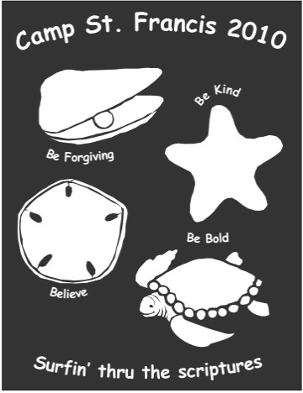**Vacation Bible School**

For the third year, St. Francis partnered with St. Andrew Lutheran Church for an exciting Vacation Bible School Day Camp held at the St. Andrew campus. Through our partnership with St. Andrew, and the many people who contributed and helped, we worked with a talented team of energetic, trained young people who led us in Worship, Bible Study, Music, Art, and Games. Many thanks to all who helped. Please stay alert for upcoming announcements about this year’s program.

**Choir**

This past year has seen the choir grow to hold its own with nearly twenty members (singers and musicians) contributing. This allows the performance of more diversified music. The new robes have been a blessing! The choir stepped out this year and took their music on the road by going to Eden Hill and performing at Christmas time. Besides wonderful music the ministry to the residents was deeply moving. We’re always looking for new members!!!

**Christian Education for Children and Youth**

Sunday school was provided for children elementary age and younger during the 10:30 a.m. service. Interactive lessons have focused on the gospel reading for the week.

For part of this year we added a Sunday school class for students in Jr. High and High School at 9:15 a.m. We explored the scriptures from the lectionary through prayer, art, music, literature, and drama and applied them to living in the world today.

In 2017 we’re going to try something a bit different and offer Sunday School for children at 9:15am. A team of teachers is being developed to share the privilege of being with the children. Contact the Rector if you would like to be considered for this vital ministry.

**Building Committee 2016**

*By Maury Meyer, Building Committee Chair*

On Sunday, Jan. 24, 2016, Fr. David presented the findings of the Capital Campaign Division of the Stewardship Department of the Episcopal Diocese of West Texas to St. Francis parishioners at the Annual Parish meeting. Nancy Stinson and Ted Burkhart, the Diocesan representatives, conducted 41 personal interviews with St. Francis parishioners Nov. 14-15, 2015, to gauge support for our new Ministry and Outreach Center. Eight families submitted online surveys, for a total of 49 responses, a 77% response rate based on 64 pledging units.

**Results of the Report:** The majority, (63%,) were members for five to 15 years, 16% from one to fewer than five years, and 14% for more than 15 years. None had joined St. Francis in the last year. According to the Diocese report, this indicates an extremely stable parish; i.e., one that is not currently in a growth mode, although I believe we have grown in the last year. The interviewed families represented virtually all the ministries and activities at St. Francis, with over 92% active in one or more areas, and with two-thirds of those participating in four or more areas at St. Francis. This indicates an unusually high involvement in all facets of the church. Ted and Nancy wrote “Leadership has definitely created an environment in which everyone can build relationships and find a home.”

The respondents all portrayed the congregation as welcoming, loving, generous, sincere, and friendly and there is a “sense of family and community.” They also honestly admit that St. Francis exists in “a retirement community” and they see the congregation as older, “mostly retired but well educated with a lot of time and energy.” The majority agreed that St. Francis has a strong ecumenical presence, participating in the joint Thanksgiving Service, providing first Sunday services at St. Jude’s Ranch for Children, joining with St. Andrew Lutheran Church for Family Promise and Vacation Bible School, supporting First Baptist Church with their backpack program (part of the Student Nutrition Program,) and providing space for AA meetings. Respondents boasted that parishioners serve as community leaders “at almost all” the organizations active in the Canyon Lake community including the Chamber of Commerce, Community Resource and Recreation Center, the Tye Preston Memorial Library, and Community in Schools. Visitors find the parish caring, loving, approachable, supportive, and uplifting, with a strong faith, a missionary focus, and tremendous energy. The report stated that “The strengths of the congregation are many and varied, but most respondents concurred that the people are the true strength, with St. Francis providing many opportunities to develop lasting relationships. One interviewee said, “…members of the parish have such diverse gifts creating a wonderful mix of talent, education, and a variety of resources.” A second described the congregation as a “wonderful core of Christian people, willing to be involved in outreach projects, wanting to help the community not just the church.” This focus on reaching outside the walls of the church was a thread running through every interview Nancy and Ted conducted. They also stated that “it is not at the exclusion of the church family. A family who takes care of its own in illness and crisis, rebuilding after floods, offering Eucharist to shut-ins, needing only a phone call to bring volunteers to help restore all to a wholeness in Jesus Christ.” This was summarized by one interviewee as “We worship together, we pray together, and we play together.”

Besides summarizing strengths, the report also described weaknesses. More than half of the respondents focused on the lack of children, youth, and young families, followed closely by the maturing age of the congregation. Some wondered if the parish is in a “Catch 22” in which we cannot attract youth and young families because we don’t have them yet. Respondents asked, “Why are we not able to get more youth - because we have nothing to offer them? Schools are growing, why not our youth?” It was obvious to the consultants that the 75+ year-old parish hall was perceived as the second major weakness. Some respondents answered that they see the parish hall as a deterrent and thought if there were a new ministry and outreach building, it could serve as a safe haven for teenagers providing a movie night, etc., and provide needed classrooms for children’s Sunday school. The report surmised that the focus outside our walls is partially due to the fact the building will not allow outreach events to come to St. Francis by the Lake. One respondent said, “We want to increase ministries, but we are restrained by the facilities.” An almost forlorn note was heard, that parishioners must always go to other churches to serve, and they cannot invite those churches to their “home” to participate in outreach or host a family meal, because the building is unsafe and falling apart. One said, “We don’t have a facility where people in need can turn, no homeless meals, or other events recognized by the broader community.”

Unlike most church feasibility studies, Ted and Nancy heard little complaining about cliquish members, overworked leadership, poor communication, or need to improve the music program. The report went on to address parish leadership. It said “The congregation is blessed with a rector who is described as dedicated, knowledgeable, and a gifted spiritual leader who cares deeply for his congregation. The Rev. David Chalk is a visionary working for growth, and concerned with the health and spiritual wellbeing of parishioners, always pushing people to get out of their comfort zone and inviting them to talk with him about anything. He is perceived as a good administrator and a highly intelligent and motivating speaker. One respondent said, ‘His sermons can be thought provoking and energizing, as well,’ but we found his excellent Bible Studies were mentioned the most often. One non-member Bible Study attendee stated Fr. Chalk is, ‘Intelligent, resourceful, articulate, motivated, well-educated, people-oriented, faithful, and loyal to the Episcopal Church - a person I could confide in for spiritual guidance.’ And that was from a non-member! A member concluded he is, ‘Caring, dedicated, reachable, knowledgeable, and compassionate - there are not enough positive adjectives to describe him fully!’ The equally talented and positive lay leaders are described as diverse, committed, loyal, caring about community and parish - ‘always throwing their hearts into what they are doing.’ Most comments were focused on the Vestry, describing it as doing a great job, moving forward together without friction, ‘taking on new challenges and succeeding wonderfully.’ The new parking lot was used as an example of the sense of moving forward. A recent vestry member witnessed they now work toward a goal, looking at problems and finding solutions, with responsibility divided among all members. Another respondent described the members as having spiritual awareness and a recognition of everyone’s needs as a family. They are tender, compassionate, and here to serve.”

**Since the Report:** During the spring and early summer, Building Committee members met with all the ministry leaders to talk about the plans for our new Ministry and Outreach Center, and to obtain their input.

In June and July, the Building Committee met with our final two possible builders for the second time and came to consensus and selected a builder and architect partnership. The Vestry then affirmed our decision unanimously. We had two excellent choices; however, we decided to use Wunderlich Builders (based in Seguin) and John Zimmerman as architect (based in Bulverde) for three reasons.

1) Mr. Bob Wunderlich and Mr. Zimmerman, who is based in Bulverde, were very tuned in to keeping the cost as close to $1 million as possible and will work with us to make that happen.

2) Wunderlich Builders uses Butler metal buildings exclusively, and we were convinced that is the superior choice for strength, quality, durability, and energy efficiency. Butler is the industry leader in scientifically developing and testing its products over extended time periods.

3) Wunderlich Builders has a 41- year history of providing quality buildings in the community. Comal County has used them time and again to build their offices, including the new County Offices Annex in Bulverde. The Building Committee toured that building in July and were impressed with the quality.

In July, I met with Mr. Wunderlich and Mr. Zimmerman to provide as much additional information as possible to start the final planning. We continued to meet as needed throughout July and August with them and various committee members to fine tune, as Mr. Zimmerman developed more specific set of plans that incorporated building codes for access, fire, Americans with Disabilities Act rules, and all other building codes. In October, the full committee met with Mr. Wunderlich and Mr. Zimmerman to look at the “final” plan, elevation drawing, and site plan, and came to a consensus that it was acceptable and fulfilled our needs. Mr. Zimmerman then provided full scale plans, which were presented to the congregation after the *All-Together Now* Service Nov. 27. The plans and explanatory texts describing various aspects of the plans were posted in the Narthex in November, and will remain there as we enter the Building phase. The floor plan also was published in the December 2016 *Franciscan.*

During the fall, our Capital Campaign was conducted very successfully, and was a critical step that demonstrated the commitment of our parish to building a new center where we can fully develop all the ministries we want to pursue, and continue our spiritual commitment to ourselves and our community Those activities are more fully addressed in the Capital Campaign report.

After the floor plan was published, I continued to get feedback from various ministry leaders and parishioners, and we will try to accommodate those comments as we move towards the Building Phase, although it may not be possible to achieve all of them.

Currently, we are waiting for a set of specifications and itemized costs from the builder. I expect them soon (hopefully February,) and then Fr. David and I will provide them to the Diocese for final review. Assuming the Diocese gives us permission to proceed, we will then sign a contract with the builder that also includes the architect’s work. The Diocese will also give us advice and aid in obtaining a mortgage to pay for building the Ministry and Outreach Center. We are also currently obtaining bids for site preparation, including moving the Davenport memorial tree and the memorial fig bush, rocks, and sculptures from the Memorial Garden to a different part of our campus, and removal of the remaining trees and their roots from the garden. Our goal is to break ground this spring.

I am very grateful and blessed I have had Linda Bosenbark, Bernie Frey, Marcel Klaftenegger, Tom Meyer, Jeanne Slupik, Brenda Smith, and Don Stackhouse to work with me on the Building Committee. All of us, except Bernie (for personal and community reasons,) also have committed to stay on until we complete our work.

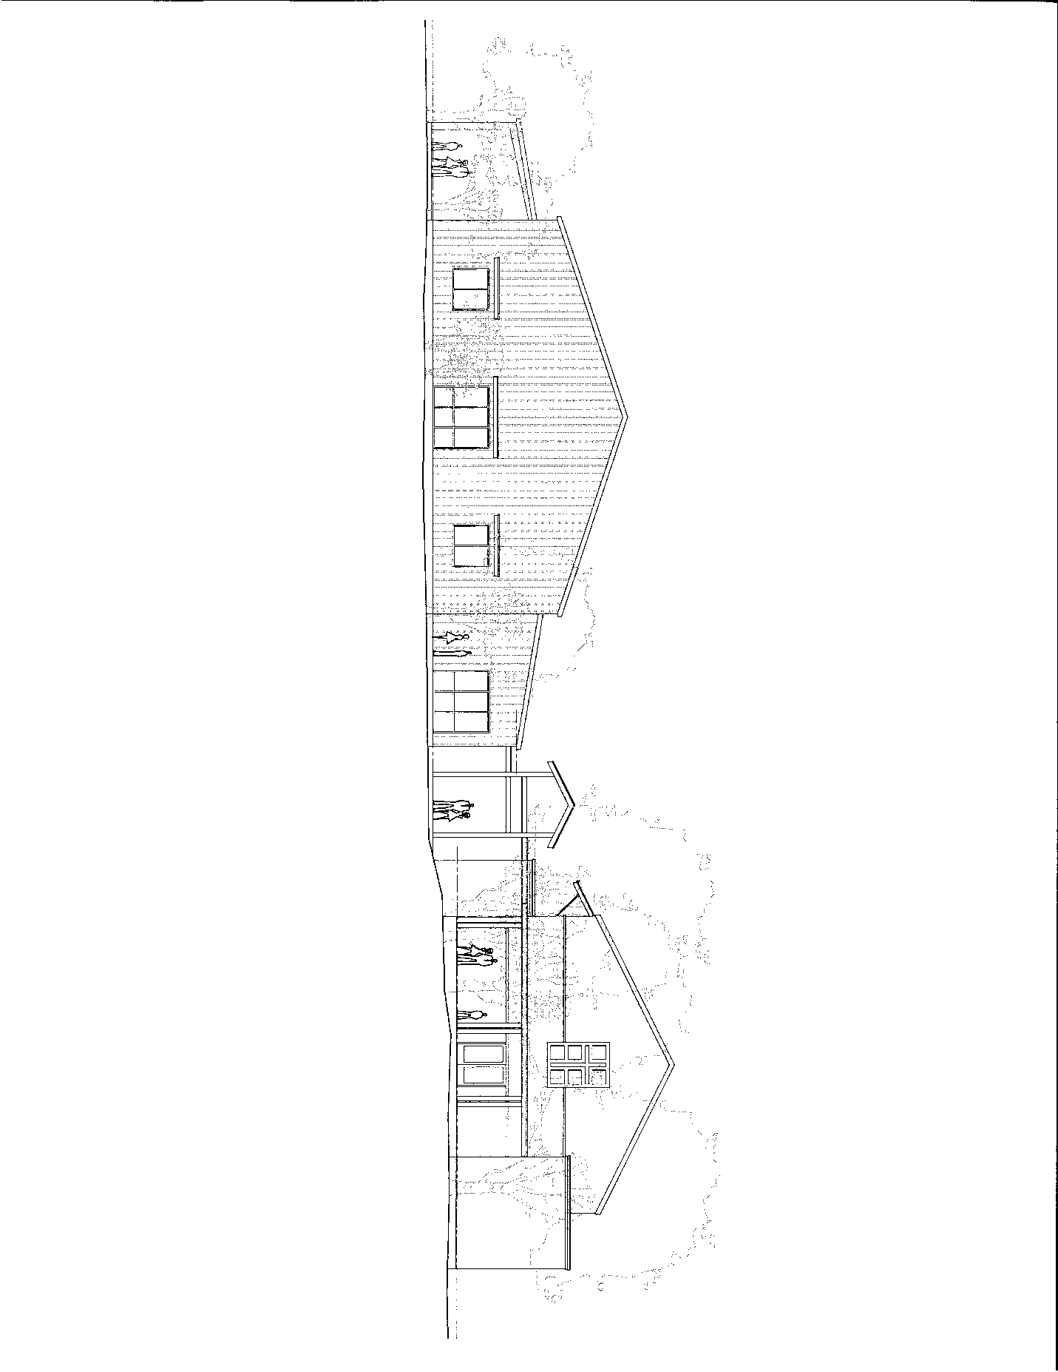

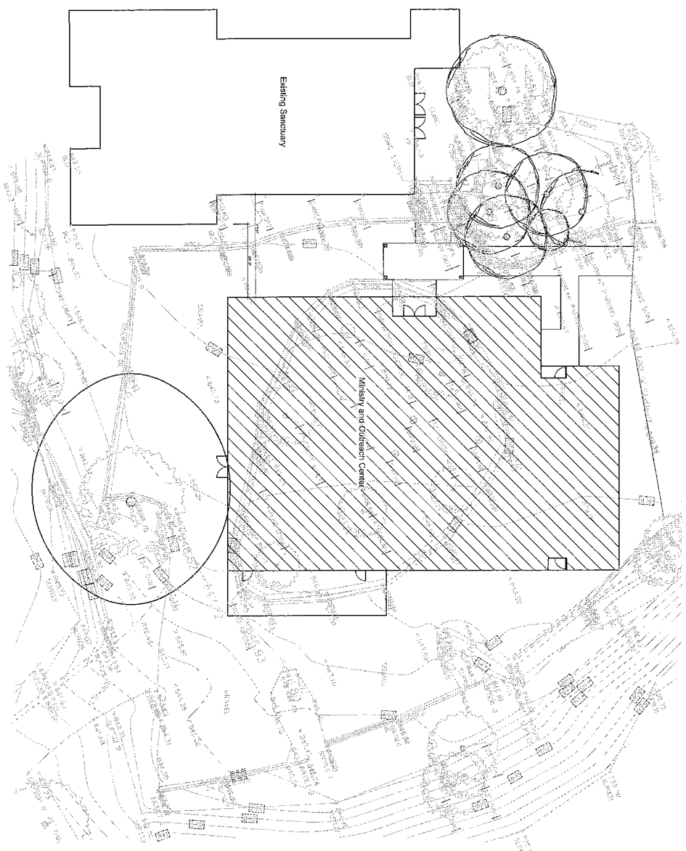

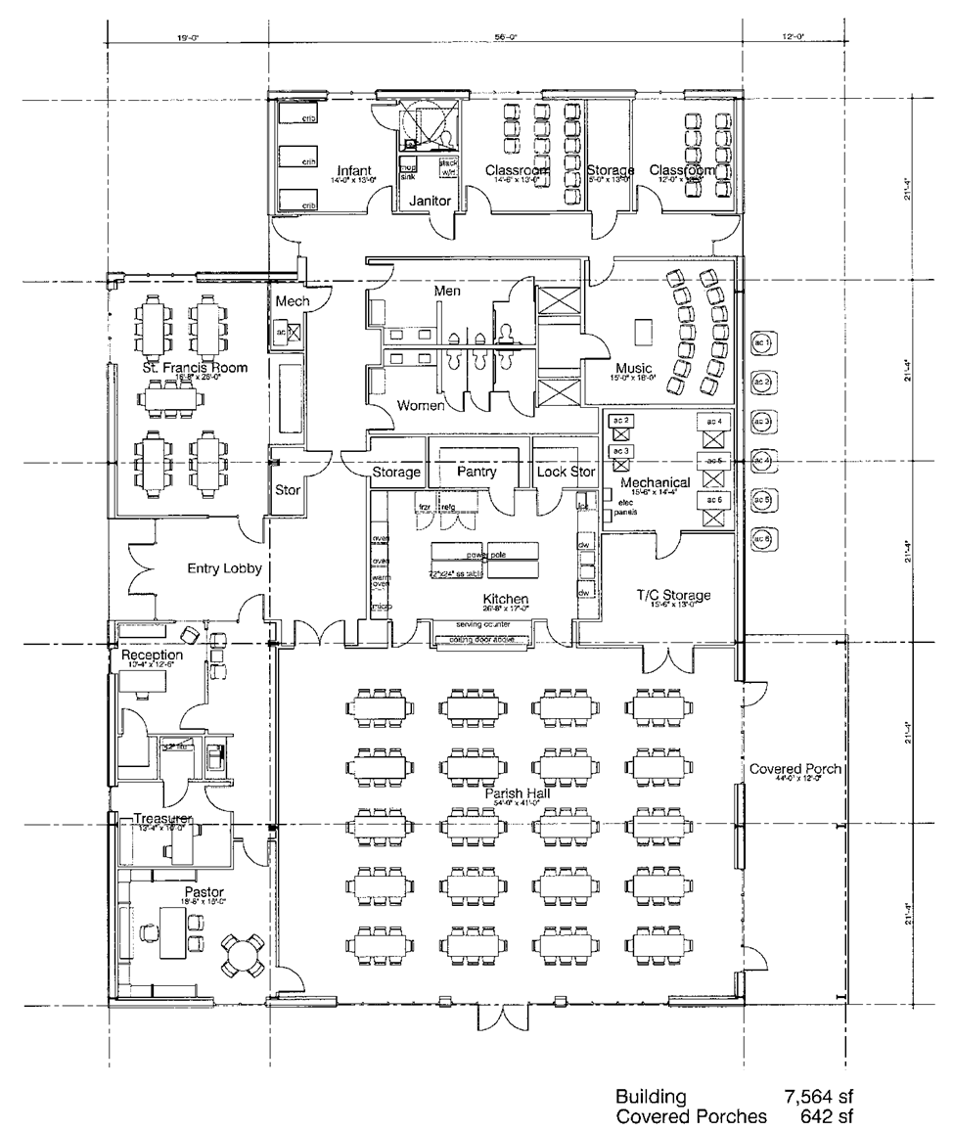

**Church Periodical Club**

*By Betty Morris*

The red canisters you see at the entrance to the church can provide hope for a child! How is that possible? The money you put in there will go to provide books and other reading materials for those who could not otherwise afford them. The goal is to further the mission of Christ throughout the world.

Recently, our Honduras scholars received a grant for books from the Miles of Pennies fund which assists children and students. Patricia Perea says a grant has provided Kindles for the students and she is requesting another CPC grant for books in electronic format. We can help with this by leaving pennies or green paper pennies, or checks - in the red canister. Part of the funds will be sent to the national office to assist with grants and the remainder will go to a specific need identified by Patricia.

The CPC has another fund, National Books Fund, which can assist these students in their careers after graduation. We have had a teacher from Honduras here to speak to us and an NBF grant could assist her in her role as a teacher.

Be a part of this world-wide ministry even while we focus on Honduras students. Help to change the world - one book at a time.

**Columbarium Committee 2016**

*By Keren Necaise*

The Columbarium has been enjoyed this year by many people visiting and experiencing the peaceful setting. We invite you to visit our columbarium and just relax and feel the presence of God. The only maintenance we had to do this year was to replace the pump on the fountain.

We had three interments this year; 2 ½ niches were sold in the Granit Columbarium; 1 ½ niches were sold in the Garden of Eden.

This leaves us with only 7 ½ available niches on the B Side of the granite columbarium (holding 2 urns each) and 8 ½ niches available in the Garden of Eden (holding up to 4 urns each).

The balance in the Columbarium fund as of Dec. 31, 2015 is $43,537.14.

The Columbarium Committee members are Keren Necaise, Chair; Tommie Helen Woollven; Winnie Benson, Ray Thompsett, Jo Laney, Linda Bosenbark, and Brian Benham.

**Community of Hope 2016**

*By Julie Chalk*

The mission of Community of Hope International (COH) is to create and sustain Christian communities of lay pastoral caregivers united in prayer, shaped by Benedictine spirituality, and equipped for and serving in pastoral care ministries, which involves listening non-judgmentally and responding to the spiritual needs of those around us. Indeed, COH focuses on growing each participant spiritually, within a nurturing community “because those who are the healthiest spiritually will have the most to give to others in need.”

In the fall of 2015, Fr David Chalk and the parish commissioned 17 people into the Community of Hope ministry at St Francis by the Lake. In the year since then, COH participants have served in many different settings and capacities. Some regularly visit strangers and parishioners who reside in memory care or nursing home facilities; some have music ministries to nursing home residents. And those who are licensed Lay Eucharistic Visitors take Communion to parishioners unable to attend worship. Many in Community of Hope participate in various aspects of prayer (prayer during worship services, prayer shawls, Daughters of the King.) All use their training to be present with members of their family (some are in caregiving situations with family members,) in the community, and at their work. Several in Community of Hope visit St. Francis parishioners when they are ill or injured in the hospital, recovery facilities, or at home. In addition, prayers are said, cards sent and phone calls made to many at St Francis to lift them and let them know they are loved. In addition, COH members attend monthly Circle of Care meetings which are designed to provide continuing education, spiritual growth, community building, ministry support, and fellowship.

Each COH training center is required to report three numbers annually to the Community of Hope International. These numbers are used to obtain grant funding. St. Francis COH members report monthly on their activities and it is averaged over the year. St Francis by the Lake reported the following numbers in October, 2016:

14 = Average number of active lay chaplains per month

89 = Average number of face-to-face visits per month

56 = Average number of hours spent at face-to-face visits per month

One important note is that St. Francis’ Community of Hope members are involved in many ministries and activities that do not fall into the reported categories (such as phone calls, cards made and cards written/sent, food prepared and delivered, transportation to doctor appointments and errands, prayer shawls, etc.) If all the time spent and activities were recorded, the numbers would be much higher.

Due to the commitments necessary for a successful Capital Campaign, a second Community of Hope training class that was scheduled for September-November 2016 was rescheduled to begin Jan. 23, 2017 and end Mar. 25, 2017. The Annual Covenant Renewal for current COH members will take place during the 10:30 a.m. worship service on Jan. 22, 2017 with a reception following.

If you would like more information about COH and lay pastoral care, please contact Tricia Jones, Julie Chalk, Betty Morris, Fr David, or the office.

**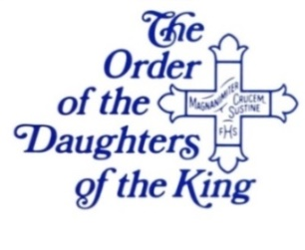The Daughters of the King**

*By Rebecca Averyt, Chapter President*

The Daughters of the King is an Episcopal order for women whose mission is the extension of Christ’s Kingdom through prayer, service, and evangelism.

Each daughter has taken a vow to follow the rules of prayer and service. We pray daily for the unity of Christ’s Church, and the spread of Christ’s Kingdom, especially among women and girls. We pray for God’s blessings upon the members of the order, for the spiritual growth of the parish, the clergy, and for the special needs as requested by others. If you or someone you know is in need of prayer, please contact one of the Daughters, knowing that all requests are confidential.

Daughters fulfill their vow of service in many Ways. We provide for funeral receptions, memorials, and other occasions. Each Sunday we deliver the alter flowers to those who are ill, need encouragement, or in celebration of some event. Our service project this year is providing a consistent, monthly support system for the Operation Backpack Program, in conjunction with the current giving to this cause by St. Francis by the Lake.

Yearly the DOK, ECW, and most recently the COH, sponsor a Lenten Quiet Day. Last year we spent the day in quiet contemplation and prayer. This year on March 4, we will have a presenter, with words and thoughts, scripture and music.

Monthly meetings are held in the parish hall on the fourth Wednesday of the month following the Eucharist. We have a group study, and a brief business meeting. This year we concluded our studies taken from Devotional Classics and in February will begin a new adventure with **The Friendship of Women** The Hidden Tradition of the Bible by Joan Chittister. In this book Sister Joan explores the sacred dimension of friendship through the lens of faith, tradition, scripture, and the social sciences, telling the stories of the women of the Bible.

The St. Francis by the Lake chapter is a very active chapter. We currently have 30 members. We encourage all women of our parish to consider becoming a Daughter as a spiritual step in their walk with Christ. For more information about DOK, contact Rebecca Averyt, Debbie Barnwell, Ronnie Schwakhofer, or the parish office.

****The Order of the Daughters of the King is truly blessed to serve you through prayer and service For His Sake.

**Episcopal Church Women (ECW) 2016**

*By Betty Morris, President*

The St. Francis chapter of ECW meets monthly with a focus on programs of interest, prayer, brief business meeting and fellowship. In the fall, our meeting time changed to 10:30 am so that those who wished to could stay for a sack lunch. That has been a good time for the women to visit and get to know each other better.

Our programs have been on a variety of subjects. We began with two women who are officers in the diocesan women’s program, The Commission for Women’s Ministries, Jane Ahuero, President, and Marjorie George, Vice-President, Programming. They spoke about women’s organizations in the church in the diocese and beyond. The St. Francis women told them what we are doing in our parish and in the community. The Commission sponsors two retreats that are well-attended by women from St. Francis, one in the fall and one in the spring. In October, the ECW, friends and spouses toured the Painted Churches in the Schulenburg area. At the November meeting, our own Lynn Zimmermann, ECW Chaplain, spoke about the prayer and posture of a grateful heart. December was the Christmas party at Valeska McHugh’s lovely home. In January, Linda Hillin prepared a program of pictures from when St. Francis was first organized to the present day. It was delightful to see the start of so many of our traditions and how our activities have evolved. It was especially heart-warming to see some of our dear friends in their youth and remember those who are no longer with us. We noted that many activities were centered around eating, which we all still enjoy.

During the fall, we held two very successful fund-raising events. The Rummage Sale, chaired by Ronnie Schwakhofer was the most successful we have ever had. The pre-Thanksgiving Bale Sale, chaired by Lynda Leadford was also successful and added funds to the treasurer. These funds will be used in outreach ministries such as Communities in Schools, Family Promise and at St. Francis as graduation gifts for our high school seniors, Prayer Books for confirmands, and equipment for the kitchen in the new Parish Hall.

We look forward to the interesting programs scheduled for the remainder of the ECW year. Our own Judy Frey and her friend will speak on the Canyon Lake Blue Star Mothers organization; Pam Currier, from the Commission for Women will share information about the Most Honored Woman program; and Lynn Zimmermann will lead us in meditation on Maundy Thursday. A salad luncheon will close out the year with installation of new officers. At each meeting, birthdays for the month are celebrated and during the summer, a social meeting is held in July and summer birthdays are celebrated.

The ECW at St. Francis is somewhat unique in the diocese. Many years ago, many ECW organizations disbanded when women became able to serve on vestries and be ordained as Deacons and Priests. Ministries that had been a part of ECW, such as the United Thank Offering (UTO) and Church Periodical Club (CPC), continued. Over time, women recognized their need for fellowship and came together in ECW, lunch groups, or some other parish organization. The ECW at St. Francis has continued since its formation in 1979 to provide support for women as they participate in all areas of parish life.

The Board for 2016-17 is Betty Morris, President; Lin Boudreaux, Vice-President; Tricia Jones, Recording Secretary; Mary K Chittenden, Corresponding Secretary; Lynda Leadford, Treasurer; and Lynn Zimmermann, Chaplain. If you would like more information on the ministries of ECW, please speak with any of these women.

All women who attend St Francis by the Lake are members of ECW, whether they are official members of the parish or not. We also enjoy meeting visitors and friends of ECW members. We meet on the second Thursday of each month at 10:30 am. Because the meetings are held in homes, please check in the office for the next meeting site. We look forward to welcoming all women to the ECW.

**Evangelism**

The Evangelism Ministry includes the following ministries: Visitors/Newcomers, Greeters/Ushers and Public Relations/Advertising. Below is an update on the activities throughout the year for these ministries:

We continue to welcome newcomers to St. Francis with a St. Francis mug on their initial visit. Also a home visit is made to local visitors to take gifts which include a jar of cookie mix..

Ushers/Greeters – currently we have people who alternate as greeters/each Sunday (two people serve at each service.)

We utilized the CRRC’s North Pole Village event program to promote our holiday services and other events. We are members of the Canyon Lake Chamber of Commerce; our church brochure is kept in their display case for visitors. Banners promoting our events are hung on our banner/sign frame on the corner of FM 306 and Mountain Spring Road. The local chamber also advertises our events on their calendar and web-site events.

**Newcomers (Evangelism)**

*By Linda Hillin*

We had twenty one visitors from this area sign the guest book during the year, eight of those have become regular attendees at St. Francis. We continue to welcome newcomers with a coffee mug, a cookie mix and pertinent info about St. Francis which is delivered to their home soon after their first visit by a member of the Welcoming Committee. The Evangelism team hosted two newcomer dinners last year with twenty four guests. The next scheduled dinner is planned for Feb. 19.

**F.E.A.S.T. (Friends Eating and Sharing Together) 2016**

*By Betty Morris*

FEAST groups are made up of members, friends, and newcomers to St. Francis Church who meet for a meal. The meals may dinner in a home, a Dutch-treat meal at a restaurant or a picnic in the park. The only rule is that no hard liquor is to be served.

The couple whose name is first in each group will host a FEAST in January or July when the members in each FEAST group change. The hosts decide when and where the FEAST is to be held and select the main course and provide beverages. Other attending bring complementary dishes. If space is available, Fr. David and Julie Chalk and Fr. Gordon, Pam, and Andy Schieble are included too.

While at the FEAST, arrangements are made for the next FEAST within about a month. This will ensure the group continues to meet. At the present time, we have four FEAST groups. Newcomers are always welcome and, if they would like to attend a FEAST before deciding to be part of a group, they may call Betty Morris who will see what groups will be meeting soon and arrange for them to participate.

FEAST groups have been a part of St. Francis by-the-Lake since the year 2000. They are a wonderful way to become better acquainted with other Franciscans and we hope others will join us soon.

Betty Morris

[bmorris@gvtc.com](mailto:bmorris@gvtc.com)

(830) 515-8659

**Flower Guild**

*By Winnie Benson*

The Flower Guild, having been founded in June of 2002, is now entering its 16th year, and ever since has been able to keep our account in the black. We have many dedicated volunteers who enjoy creating the floral arrangements for the altar each Sunday.

Because of their efforts we have been able to purchase the supplies needed for this ministry at little or no expense to St. Francis. New members are always welcome and even if you are a novice you will be given some guidance and paired up with an experienced member. Each member is scheduled about once every two months. You may contact me if you are interested in joining this fun group.

During this past year, apart from the regular arrangements on the altar each Sunday, the occasion of Easter and Christmas brings more décor for the church. At Easter we adorn the church with palms and Easter Lilies and at Christmas there are the poinsettias, candle arrangements in the windows and pew decorations of greenery and red ribbons.

Memorial donations of the altar flowers, two each Sunday, remain at $25.00 each, and we encourage all to continue to remember there special occasions in this way. Names and dedications are listed in each Sunday’s bulletin. A sign-up sheet can be found in the Narthex.

**The *Good News***

*By Linda Hillin*

The *Good News* is a weekly online publication that provides information on the current week’s activities, a word from Fr. David, upcoming events, the ministry schedule for the following Sunday, a link to the scripture readings for the following Sunday, the current prayer list, CRRC food pantry needs, outreach programs, a calendar list as well as a link to the St. Francis parish calendar, and Diocesan information and links to their website. It is published on Monday of each week and information from parishioners is welcomed by 9:00 a.m. for inclusion in the current week’s *Good News*.

****

***The Franciscan***

*By Maury Meyer and Linda Hillin*

*The Franciscan* was published monthly during 2016, except for the customary combined June/July issue, with Maury Meyer as Editor, and Linda Hillin as Assistant Editor. Janet Pollock takes the lead in design and layout of *The Franciscan*, the *Ministry Schedule*, and the monthly *Parish Calendar*, and she continued her good work in assembling the articles and photographs in a reader-friendly design. Linda Hillin continued to pull together the weekly e-news, the *Good News*, and provided many, if not most, of the wonderful photographs for both communication publications throughout the year.

We are indebted to and grateful for the people who write regular columns, who send articles to keep everyone informed of the forty ministries that define our parish, and send the weekly updates on upcoming activities. The editors can only assemble the news, and edit it for spelling, grammar, punctuation, style, clarity, and brevity. There is no way we can know all that is going on and report it to the parish: that is the duty of our ministry leaders, and all other involved St. Francis parishioners.

*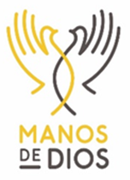*

**St. Francis by the Lake & *Manos de Dios***

*By Patricia Perea*

***Manos de Dios Mission Statement***

*Called by God and empowered by the Holy Spirit to proclaim the living Christ, together with the people of Honduras. We seek to serve God and equip laborers for the harvest through education and training and encouragement of spiritual growth.*

**Background –** We have been working in the *colonia Nueva Esperanza* in Danli, Honduras for the past 16 years. The initial commission for the Manos team was to plant a church in Nueva Esperanza, an underserved neighborhood in the heart of Danli. After many years of work, dedication, generous donations, and constant prayers, we have been able to plant and build a church. In addition, we have built a vocational center and have been able to work in various social areas with the purpose of empowering the members of the community and help them be self-sufficient.

As we look into the future, we will continue supporting our sister church Manos de Dios, but we also started a new ministry called Manos to Go five years ago. The idea is to maximize our resources and spread the blessings and go to remote villages and work with the local community in various ministries. In January 2017, we decided to work in El Paraiso, a small village about 20 miles from Danli. We held a vision clinic, as well as a VBS session. We worked side by side with our Honduran partners throughout the day. Manos to Go has become an outreach effort for the Manos de Dios Church. This is something that they do throughout the year as they try to help surrounding villages such as Santa Maria, San Lorenzo and San Diego.

A small team of four missionaries went to Honduras in September 2016 to check on the Manos de Dios mission to help us plan for the January 2017 trip.

**Ongoing Support to Ministries –** The Manos de Dios team continues to support our sister Church in Danli, as well as a community center with two micro-enterprises (sewing and baking). The profits from these micro-enterprises have helped the ladies of the community bring some income to their families, as well as helping them reinvest some of the funds into materials for future projects. Another important ministry is the Manos Scholarship Program for students in 9th-12th grades, as well as college. Currently, the program has 46 middle and high school students including 15 college students studying in areas such as Civil Engineer, Industrial Engineer, Law, Agronomy, Computer Science and Nursing. In December 2016, we had seven students graduating from high school of which five are attending college, one is going to a Catholic seminary and the last one is doing mission work for two years. In addition, we have had 8 students from our Scholarship Program graduating from college to date. It is amazing to see how these children are all grown up and doing well in college when they never thought they would go beyond a sixth-grade education. All of our college graduates are working and helping their families.

We have added two new programs that are available to the students of the Manos Scholarship Program.

1. Club Intercambio ( ESL Classes)

As we see our students graduate from high school and college we have noticed that they are at a disadvantage compared to other students from other schools that might have been more fortunate to learn English. Given this situation, in March 2014 we decided to start an ESL program for our scholarship students. We have a class of 16 students that meet on Saturdays for three hours led by a local Honduran teacher. The class has been very successful and given the demand, we decided to open a second class of beginner students starting in January 2016.

1. Club Aventura (Book Club)

The notion of book clubs is not really something that our students have been exposed to as part of their upbringing either at school or at home. In an effort to encourage and inspire students to read and discuss books with their peers we started a new book club called Club Aventura. It has been a wonderful experience to see these students so excited about the idea of reading and sharing their thoughts. They have read several books throughout the year and in January 2016 we introduced reading tablets where we can download books as needed.

**Trip to Honduras in January 2017 –** A total of 15 members, including 5 members from St Francis, traveled to Danli, Honduras from January 12-19, 2017. The St Francis members include: Fr. David, Harold Simmons, Tatiana Hoecker and Patricia Perea.

We had a trip full of challenges and blessings. We were able to accomplish the following objectives in just one week of non-stop work:

1. Manos to Go to El Paraiso (Vision Clinic & VBS)
2. Conduct 3 vision clinics: Manos de Dios, Santa Rita & El Paraiso
3. Conduct 2 VBS sessions: Manos de Dios (during service) & El Paraiso (Manos to Go)
4. Conduct a Bible school workshop for Sunday school teachers
5. Teenage presentation about teen pregnancy for scholarship students and parents
6. Ponte a Bailar Música Tejana (exercise through dance)
7. Start the 15h year of the Manos Scholarship Program.
   1. Selected 14 new candidates for 2017
   2. Met with 3 seniors scholarship recipients who will graduate Dec 2017
   3. Honor Roll Dinner with top 3 students and their families and the Manos de Dios Team
   4. 2017 Scholarship award ceremony
   5. Club Aventura sessions (Book Club)
   6. Club Intercambio (ESL Club)
8. Start the first Manos a la Obra project (Community service cleaning up church surroundings)
9. Work in construction projects
   1. Maintenance projects at the Iglesia Manos de Dios: redo the sanctuary flooring.
   2. Manos to Go projects: paint two rooms of the rectory in El Paraiso and replacing lamps at the church

**St Francis Involvement in the Future –** The Manos team would like to thank members of St Francis for their continued support. Also the team would like to invite more members of St Francis to join our ministry. We need Goers, Senders and Pray-ers. Senders include people who help others go to Honduras by providing spiritual and or financial support, people who are willing to help raise money; people who are willing to sponsor a child to go to high school or college. In addition, we always need Pray-ers who are willing to support and pray for our efforts and mission in Honduras.

*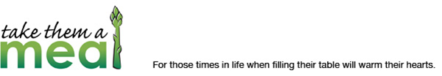*

**Ministers of Love 2016**

*By Tricia Jones, Meal Coordinator*

St Francis by the Lake, Ministers of Love, is one of many avenues that our parish has to love and serve our parish family. This ministry is dedicated to assisting our folks during times when it is difficult to prepare food for themselves and their caregivers. Giving AND receiving are blessings that nurture our souls.

During this year, Ministers of Love provided 20+ meals for 7 recipients.

Using the electronic tool TakeThemaMeal.com, meal schedules were set up on very short notice when there were emergencies, and they were planned well in advance of scheduled events such as surgeries. Sometimes only a few meals were needed and there were a few circumstances where support was provided for several weeks.

Information about those who had a need for meals was closely coordinated with the Ministers of Love Meal Coordinator, Fr David, the Parish Office, and the Daughters of the King prayer team contact person.

Report respectfully submitted by Tricia Jones, Meal Coordinator

**Eucharistic Visitors**

*By Betty Morris*

During 2016, there have been more visits by Lay Eucharistic Visitors as the congregation becomes accustomed to accessing this ministry. We presently have five people serving in this ministry and each is assigned to one Sunday a month. The Visitors check with Fr. David so see if anyone has requested Communion or if they hear of someone in the congregation who is not able to attend on Sunday. If so, they prepare a Communion set to receive the elements during the service and place the kit on the altar. They are commissioned at the end of the service to go in the name of St. Francis by-the-Lake and leave immediately to go to the home, nursing home or other place where the parishioner is present.

We presently have two people who regularly receive Communion monthly and have set a specific week for the Visitor to see them. The families of these persons have been notified that the Visitor will be there on that date so that they can attend, if they desire.

As this ministry increases, we would like to have more people involved so that there will always be at least one person available each Sunday. If you feel called to this very special and rewarding ministry, please speak with Fr. David.

**Hospitality – 8:00 a.m.**

*By Lynda Leadford*

Second only to Worship itself on Sunday mornings, the Hospitality Ministry is so important. We value this short time to have fellowship with those we know and those we have just met. It gives many a chance to greet and welcome our Newcomers and say “Hello” to our friends as well.

Individuals just need to set up the coffee table in the Narthex, bring cookies, baked or bought, or other suitable food for 9:00 a.m. in the morning. You also need to bring the coffee and juice from the kitchen to the Narthex. I will be glad to train anyone willing to help with this wonderful ministry. Is God calling you to serve, as Fr. David asked recently? This good deed serves as a continuation of our service, allowing us to share God’s love. If you are interested in serving in this ministry, please contact Lynda Leadford at (210) 508-5497.

**Hospitality – 10:30 a.m.**

*By Candace Fitch*

Joan Chittister, Benedictine scholar, writer and speaker, expanded on the importance and impact of Christian hospitality in her book, Monastery of the Heart. It is an invitation to a meaningful life by expanding on those who provide hospitality, and those who receive it. She begins by noting that being hospitable to those who are “our kind of people”....people who “look like us and think like us” isn’t what the scripture and the Rule have in terms of community. Benedict intended that the Monastic community welcome everyone equally...the rich and the poor, the slave and the free, the young and the old, artists and craftsmen, peasants and noblemen.....a motley crew.

Joan continues to say, “the Benedictine is actually on the lookout for guests, for their needs, for their wisdom. Thank God you’ve come....disturb our perfect lives. Guests bring us to God in the guise of the immediate and the urgent, the uncomfortable and the unknown. They expose our emptiness of heart and total self-centeredness, when we may not know ourselves that it exits.”

Come join this amazing ministry of Hospitality at the 10:30 service. You will be transformed by this lovely act of kindness, sharing your talents with your fellow parishioners and even at times, strangers. Let’s pray God “disturbs our perfect lives” with more and more strangers that we can bless each week by serving them with our gift of Hospitality. I will be happy to guide you through the process with a short instructional class and also I will be there to help you as you begin. Please call me at (210) 248-7374 or email me at canbf044@aol.com if you are interested in knowing more.

**Ushers – 8:00 a.m.**

*By Lynda Leadford*

If you attend church it is one of the easiest Ministries in which to participate.

The first group of people you meet when you enter the doors of St. Francis is usually a set of Ushers. We began 2016 with a group of 14 people (7 sets of Ushers) who double as Greeters as well. We had one set of Ushers step down in 2016, and we are now looking for any individuals or couples that would like to join our group of early morning risers. It is not difficult to be an Usher/Greeter. We serve in groups of two (you do not have to be related). This is such a great opportunity to get to know those who have been here a while and to welcome those entering our doors for the first time in order to make their experience one to remember. Do you remember your first time at St. Francis?

Responsibilities include: Handing out bulletins, smiling now and then, answering questions, counting heads, and bringing the bread and wine to the Altar.

Fr. David asked us recently to consider answering God’s call to serve in Ministry. Could this be the Ministry for you?

If interested in the 8:00 a.m. service, please call Lynda Leadford at (210) 508-5497. We can really use your help.

**Greeters – 10:30 a.m.**

*By George Glasby*

At the 10:30 a.m. service, we have 17 people signed up to be greeters. Since we started the *Altogether Now* service, the 4th Sunday of the month, the 10:30 a.m. greeters will serve the 4th Sunday on the odd months and the 8:00 a.m. greeters will serve the even months. We could always use more greeters!



**Landscape**

*By Winnie Benson*

The purpose of this ministry is to help maintain the grounds and flower beds around the church property. A few years ago we put into effect a plan known as “Adopt a flower bed.” The idea was to assign a ministry member a particular section of the flower beds for them to maintain. It was then up to that member to keep their section in good order, and could be done at their convenience.

When possible, a general “work day” is scheduled twice a year, with a request for volunteers from the congregation to help with this task. This past year this has not been done, especially due to the very hot summer that we had. It is my wish that we plan ahead this year and begin a general clean up before March.

If you would like to be one of our “adoptees” or could help out when needed, please give me a call.

**Lay Eucharistic Ministers and Lectors**

*By Libby Templeton*

The Lay Eucharistic Ministers and Lectors serving St. Francis by the Lake continued their outstanding support of our worship services throughout 2016. There are currently 8 Lay Eucharistic Ministers (LEMs) and 15 Lectors faithfully providing their service in support of our weekly worship.

We are planning a training session early in 2017 for both Lectors and Lay Eucharistic Ministers.

If you feel called to serve Christ and your fellow parishioners in either, or both, of these worship ministries, please contact me at ltempleton254@gmail.com or (817) 475-3909, or contact Fr David.

**Memorials 2016**

*By Betty Morris, Memorial Committee Chair*

During 2016, donations were received in memory of and in honor of members and friends of St. Francis by-the-Lake. They were designated for Altar Guild, Building Fund/Capital Campaign, Children’s Sunday School, Choir, Debt Retirement, India Mission and Undesignated. A total of $4,965.00 was donated toward these ministries.

The donations were in the name of:

Ann Bartlett, memorial; Pat Clark, memorial for Ray Ferguson’s mother; Presley Eastburn, memorial for Gloria and Dwain Glasses granddaughter’; Paula Gleason, memorial for Lynda Leadford’s sister; Guadalupe Garcia, memorial for Lupe Garcia’s husband; Cora Mable Gunther, Ginger Rose’s grandmother; Cathy and Jeff Hopkins, to honor their wedding anniversary; Edie Hungerford, memorial for the wife of our former interim Rector; Charles Litz, memorial for friend of Ann Wilson; The Rt. Rev. Earl McArthur, memorial; Elaine Moore, memorial for the cousin of Stacey Benham; Trebor B. Morris, memorial; W. Randy Rheinhart, memorial for Mary Barker’s brother; Marilyn Hudson Tucker, memorial; and Fritz Wildberger, memorial for Gloria’s husband.

**St. Francis Prayer Shawls**

*By Linda Hillin*

The prayer shawl group meets monthly to create prayer shawls and lap blankets for those who are in need of prayer. Parishioners are invited to take the shawls from the rack in the parish hall and take to someone in need.

**Outreach Activities 2016**

*By Bernie Frey*

During 2016 Parish members contributed to or participated in the following activities:

Provided 94 Christmas food bags for the Good Samaritan Community Center program

Donated four large plastic bags of school supplies to Communities in Schools

Prepared meals for Family Promise families each quarter

Donated over $1500 to the annual CROP walk program that helps families throughout the world

Participated in the quarterly Canyon Lake blood drive

Provided weekly donations to the CRRC food pantry and also the backpack program which provided over 500 backpack packages from August to December

Assisted local social service agencies by volunteering or serving on boards

It is important to recognize that these numbers and activities in and of themselves are just that numbers. That they represent support to individuals and families in need who have and will benefit from your efforts is a blessing indeed. Oh, and don’t forget the 50 bags of trash picked up along Highway FM 2673.

**Annual Stewardship Report 2016**

*By Ronnie Harper-Schwakhofer*

This year we conducted our annual regular pledge campaign simultaneously with our capital campaign, “Reaching up… Reaching Out”- building for today and tomorrow. The literature for the capital campaign stated the importance of *regular* giving, “Our annual regular pledges are first and foremost in the life of the parish. This is our regular one year offering, which funds our annual operating budget and make possible all that we do in ministry at St. Francis by the Lake.”

On three consecutive Sundays, we had three people share how their involvement in a ministry impacted their lives and helped others. Tricia Jones spoke about Community of Hope, Pat Holland spoke about Alcoholic Anonymous, and Linda Bosenbark spoke about Family Promise.

A detailed brochure was mailed to our parishioners, which included a narrative budget for 2016: total income $261,635-Pledges and loose plate offering provides 98% of income, interest and investment income provides 2% of income; total expenses $292,000 itemized as follows: Mission and Outreach $49,494; Facilities $46,341; Administration $9,859; and other expenses $13,303. This brochure also included a history of St. Francis (yesterday), list of current Ministries (today), and Plans for the new building - Ministry and Outreach Center (tomorrow.)

On Oct. 24 stewardship pledge and capital giving cards were mailed with a letter from the Co-Chairs of the Campaign Committee, Bob Amos and Don Stackhouse, Chair of the Stewardship Pledge Drive, Ronnie Harper-Schwakhofer and our rector, Fr David thanking us for our Dedication to St. Francis.

On Sunday, Nov. 27 we celebrated the conclusion of the 2017 Stewardship Pledge Drive and this first part Capital Campaign when Commitment Announcements were made.

Ministry and mission remains the focus of our year round stewardship. We share opportunities for participation every week through e-News (*Good News*) and announcements, and monthly through our annual parish newsletter, *The Franciscan*. During the coming year we plan to hear from representatives of each of our parish ministries as to how their involvement has impacted their lives and how we can become involved in spreading the Gospel and serving others.

**Annual Ministry Report for Veterinary Missions 2016**

*By Dr. Valerie A. Kirk*

The veterinary ministry at St. Francis had a diverse year in 2016. Four different areas of impact included Southeast Mexico, Honduras, India, and Kenya.

The ministry to Southeast Mexico was put on hiatus this year due to lack of sufficient team members for a successful mission. However, the hiatus has emphasized the need to redirect how the mission is conducted, changing from a team which has done the work with the assistance of the Mexican people, to a teaching ministry with the goal to empower and equip the people to do the work themselves, putting our team more in a supervisory role.

Although the mission to Honduras is not a mission of our parish, I am part of the planning team and lead the large animal portion of one of the four veterinary teams. Due to an on-going nation-wide drought in Honduras, the number of animals treated was reduced this year. The mission includes a public health group which teaches hygiene in the schools. New this year was a vision team which tested children’s vision and sent eye glasses provided by Lions Club International. There is a relatively new part of the team which teaches people chosen from each village how to care for the animals in the absence of a veterinarian. I will be joining this ministry in 2017, with an eye on application to veterinary missions in other parts of the world.

A new mission this year was one in the Diocese of Durgapur, West Bengal, India, a state just west of Bangladesh. The mission goal was an exploratory one through the cooperation of the Diocese of West Texas and the Diocese of Durgapur, Church of North India. The intent was to see how our diocese could interface with and be of assistance.

Only three team members out of 11 managed due obtain visas, due to non-Hindu influence being unwelcome in India. The mission dates of March 4-17 included eight days spent traveling around the Diocese of Durgapur on a whirlwind trip to get an overview of all their diocesan missions to the Indian people. Due to safety issues, my meeting with the veterinarians was cancelled. At this time, it is unknown when future missions will be undertaken due to the political climate and the difficulty in obtaining visas. The Bishop of Durgapur will be visiting our diocese in 2017 to meet with the World Missions Department and discuss the future of missions to India.

A veterinary teaching mission to northern Kenya is still under consideration. I met with Getachew Bezabih of Eleventh Hour Ministries when he was in San Antonio this summer to discuss the mission. Getachew evangelizes Muslim pastoralists and has requested a veterinarian to teach them animal care.

Finally, along with Dr. Marthe Curry and Kaitlin Reed from our World Missions Department, I attended the triennial New Wineskins Conference in North Carolina in March. The meeting included mission workshops, worship, and fellowship with Anglican missionaries from all over the world. It was a glorious and Spirit-filled time.

bs00580_My thanks to all of you who supported the veterinary missions with prayer and financial assistance. We are all members of the mission team!

**www.saintfrancisbythelake.org in 2016**

*By Keren Necaise*

There have not been any major changes in our website this year; it does continue to be viewed by more people each year. Libby Templeton is still in charge of the major look of the website; Keren Necaise and Linda Bosenbark update it.

Our website continues to inform visitors about all the ministries we have available, where we are and how to contact us; and to keep members of Saint Francis updated on what is happening at our church. Try viewing our website to read our Franciscan and ministry schedules and to enjoy the many pictures that Linda Hillin provides for us of all our important functions. Our website address is www.saintfrancisbythelake.org.

**United Thank Offering (UTO) 2016**

*By Mary K. Chittenden*

The United Thank Offering ((UTO) the little blue & white boxes for your change)) is held twice a year. The UTO is a ministry of The Episcopal Church for the mission of the whole church. The UTO is entrusted to promote thank offerings, to receive the offerings, and to distribute the UTO monies to support mission and ministry throughout The Episcopal Church and in invited Provinces of the Anglican Communion in the developing world.

Through the UTO Fall and Spring Ingathering at St. Francis, a total of $1,159.32 was sent to the Diocese in 2016.

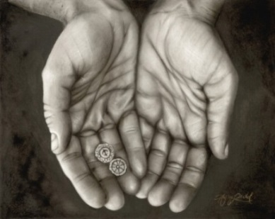**Treasurer’s Report – 2016**

*By Micheline Ellas*

We started 2016 with a vestry approved general operations deficit budget of $47,085. We finished 2016 with expenditures exceeding income by $32,774.

Knowing the challenge before us, we began the first quarter of 2016 by closing certain bank accounts and consolidating them to local financial institutions and on-line institutions where the interest rate environment was much more advantageous to St. Francis. Target balances were established at each institution with the remaining balances invested in the on-line institutions. As a result, the monthly interest income now averages in excess of $200 per month.

A $15,000 credit card relationship was opened with American Express in an effort to bolster credit levels and to take advantage of the card’s cash back features. The annual savings from the cashback feature totaled $364, an increase of 291% from the previous year. Where possible, expenditures were paid by credit card. Expenditures by check were reserved for distribution on Tuesdays and Fridays, thereby enhancing our ability to more effectively manage our cash reserves.

Certain recurring expenditures were also reviewed for opportunities to reduce cost. The relationship with one such vendor, GVTC, was reworked resulting in an annual cost savings $800+. In addition, an energy audit was conducted by PEC which resulted in a Report to the Vestry of opportunities to reduce this type of expenditure. In a further attempt reduce expense levels, the remaining debt on the Rectory was paid off early, resulting in a monthly decrease in expenditures of $1,096+ and an interest expense save of $269.

While many changes in the Finance function occurred during 2016, a consistent partner in growing this function was the prior Treasurer, Lynda Leadford. Her knowledge and understanding of the finance processes and her willingness to provide feedback on the changes under consideration were much appreciated.

The 2016 year-end reports are attached, as well as the 2017 Approved General Fund budget for your review. The 2017 General Operations Pledges totaled $221,095, the Debt Retirement Pledges totaled $7,275 and the 2017-2019 Capital Campaign Pledges totaled $499,224.

The Vestry approved 2017 General Fund Operating Budget is attached at the end of your annual meeting report. Unfortunately, this is also a deficit budget with our needs in excess of the amount of anticipated revenues by $39,159. During our budget meetings we were able to reduce certain expenditures and recognize that growth is needed to sustain the cost of operations.

Year-end statements were mailed or emailed during January. Please contact the Treasurer with any questions by email at treasure@gvtc.com.

**Junior Warden**

*By Jay Hillin*

Minor issues of maintenance during 2016 included loose flashing on church roof, a water leak in men’s bathroom, the sprinkler system had to be repaired, and we had the burned out parking lot lights replaced with LED lights.

Major repairs required in 2016 included replacing a control panel in the nave that caused the electricity to keep going off. We also replaced one compressor and a breaker box in the church air conditioning system and set up a regular maintenance schedule with the AC company T-Mech.

Thanks to everyone who helped with all these projects during the year, especially to our Sr. Warden Jeanne Slupik for her help and support, and to the many others who pitched in when needed. A special thanks to our resident plumber, Michael Brian, for always coming to our rescue when our plumbing needed attention.

**Senior Warden Report for 2016**

*By Jeanne Slupik*

Accomplishments in 2016:

* Replaced the railroad ties on the far side of the parking lot, and coordinated with PEC to repair the three outside lights on the poles: they now work.
* Arranged for a PEC representative to walk through our grounds and buildings as an energy conservation courtesy check to ensure we are using our resources as efficiently as possible.
* Met with county engineer’s road department to have the giant reed removed from the new entrance - that will unfortunately be an ongoing effort.
* Placed large boulders along Spring Mountain Road by the old entrance to deter folks from driving on the grass to take a short cut to Jones Hall or the church parking lot.
* Corrected a water drainage issue on the right side of the church. Water now drains properly away from the side and out into the lawn.
* Due to the efforts of our Parish Treasurer, Micheline Ellas, to reduce costs and save us money, the parish paid off the debt on the rectory earlier than expected. In addition, she moved our money to accounts with much better interest rates. St. Francis has an excellent credit history.
* On May 22, the Vestry invited the Ministry Leaders to join us for a light lunch and receive an update on the new proposed Ministry and Outreach Building and the proposed Capital Campaign.
* On May 29, the Senior Warden addressed the parishioners at the “All Together Now” service. She reiterated that St. Francis has received the results from the parishioner interviews conducted by the diocese and received their report. Bottom line was St. Francis needs a new facility, but it must be affordable and meet our needs.
* In June, the Building Planning Committee met with the potential builders to develop two final bids for the proposed Ministry and Outreach Building.
* Bob Amos, the Capital Campaign Chair for the Ministry and Outreach Building coordinated for the Vestry to meet in June with three Capital Campaign consultants who briefed us on their proposals. On June 26, the Vestry unanimously voted to hire Richard L. Rogers from Horizons Stewardship. Mr. Rogers was the most emphatic in viewing the campaign as a discipleship, a personal journey through gratitude, prayer, and faith. His focus during the interview was always on our Parish. The Vestry was also appreciative that Horizons Stewardship was the least expensive of the three consultants. It was also heartening to learn the three capital campaign consultants had read the report on our parishioner interviews published by the Diocese and they all concurred (based on that report) that we should have a successful capital campaign.
* Completed work on the new culvert at the new entrance in accordance with Comal County requirements. Dusty Hoecker continued to make progress in killing the giant reed around the new sign.
* After the “All Together Now” Service on July 30, held a celebration on the “Retirement of the Rectory Debt!”
* Former Senior Wardens Bob Amos and Don Stackhouse took Co-Chair responsibilities for the Capital Campaign, Brian Benham took on the Lead Gifts Chair, and Ronnie Harper-Schwakhofer agreed to Chair the Stewardship Campaign which ran concurrently with the Capital Campaign. All leadership positions for the Capital Campaign, *Reaching Up…Reaching Out: building for Today and Tomorrow,* were successfully filled and Richard Rogers from Horizon’s Stewardship proved to be an outstanding mentor, teacher, coach and more. We received $126,000.00 in commitments prior to even officially beginning the campaign.
* Three Commitment Gatherings for the Capital Campaign were held 16 to 17 October.
* On Gratitude Sunday, the Senior Warden stressed the importance of both the Capital Campaign and the Stewardship Campaign addressed the question, “What use is a Capital Campaign if you cannot keep the lights on?” She also explained that while overall revenue for 2016 year remained constant or “straight-lined,” expenses continued to climb upward.
* The Vestry, in coordination with the parish Treasurer, and mindful of budget concerns, held off on any new landscaping initiatives. The Vestry did spearhead a group of volunteers who beautified the new entrance by removing the dead reed, created a low rock wall around the sign that was then filled with mulch and trimmed the grass along the road to the parking lot.
* Due to the outstanding efforts of Bob Amos and Don Stackhouse as the steadfast shepherds for the Capital Campaign along with their team leaders and members, and Ronnie Harper-Schwakhofer for the Stewardship Campaign, the Parish culminated the year with two highly successful pledge drives. At year end the Parish had received 60 pledges of $499,224 for the Capital Campaign and 70 pledges of $221,095 for the Stewardship Campaign.

Issues:

* Building Maintenance and Utility costs: In June 2016 the AC unit for the church failed. After replacing a fan belt, breaker, and one compressor we ended up with a repair bill for over $4,000.00. The Vestry voted to approve a maintenance plan with two annual inspections to be monitored by the Junior Warden. The utility bills continued to increase and out distance our monthly income in 2016. In addition, once the new Ministry and Outreach Building is completed the Parish will have additional insurance and utility costs which will increase the monthly expenditures.
* Growth: St. Francis has a faithful, giving, and inspiring core of Parishioners who have enabled us to achieve our goal of “doing our fair share” for the Canyon Lake community by supporting the Capital Campaign for new Ministry and Outreach Building. To support our ministries and remain solvent, St. Francis must grow in membership. Fr. David has the lead on this issue for 2017.

In closing, the St. Francis by the Lake Vestry for 2016 remains indebted to those who have served on the Vestry before us for their diligence, grace, and forward-sightedness. Together we have taken a dream, a vision, a blue print, and culminated it all with a highly successful Capital Campaign for our Ministry and Outreach Building. It is an honor to have served on the Vestry for our Parishioners. We are strong in faith, firm in our commitment, and ready to continue God’s work in our community. Onward!

**Rector’s Report**

*Fr. David Chalk*

My message to the parish will be delivered orally; however, on a personal note, I wish to recognize Julie’s constant ministry to me. Without her support and confidence I wouldn’t be able to do what I do. Speaking of what we do, the ministry of Janet Pollock is critical to the affairs of St Francis. She manages to juggle and balance so many things and I am often amazed at her performance. This was a transition year in the financial arena at St Francis as well; Micheline Ellas has served us so faithfully and well. She has introduced an entirely new way of seeing how the ministry of money and its management can serve our cause and we are indebted to her. Also I want to continue to express my heartiest thanks for the collegial and pastoral support of Fr. Gordon Schieble. He continues to be an extremely valuable asset to the parish. While we appreciate his ministry to the diocese (at St Andrew’s, Seguin) we look forward to his swift return to work among us.

The vestry’s work this year, with Jeanne Slupik as Sr. Warden, has been inspiring. In the midst of our country’s fractured and hostile relations, the vestry has been unified and supportive of one another and the mission and ministry of St Francis. I’m grateful for their work and faithfulness.

In our life together as St Francis by the Lake, during 2016: we grew through the addition of six persons, however we decreased by 3 (2 transfers and one death). There were 5 funerals and several interments of non-members. This means we have a total of 307 “baptized members,” using the canonical definition. Our average Sunday attendance in 2016 was 102. There were no baptisms, 3 confirmations; 2 were received and no reaffirmations. There were no weddings in the parish in 2016. A change in policy regarding religious affiliation and regulations saw the curtailing of our St. Jude’s Ranch for children ministry. 160 Eucharists were celebrated at St. Francis. Easter attendance was 187 and Christmas was 180. There were 52 midweek services and 15 home or hospital Communions. Please remember that many visitors have never been to an Episcopal worship service and may be confused. Help them. Visitors will stay with us because of the way we show Biblical hospitality and Christian care.

As a priest of the Church, I am humbled to have been appointed by the bishop to be the Dean of the NE Convocation for another year. I have also been appointed to the Evangelism Committee, the Disciplinary Board, I continue serving on the Board of Examining Chaplains for a 12th year. I am a permanent member of the World Mission Commission. I am in my third year on the Executive Board of the Diocese. Locally I attend the community leaders’ bible study and continue my evangelizing several community leaders. While the foray into ministry partnership with the Diocese of Durgapur, West Bengal, India, has encountered serious roadblocks, the SE Mexico Veterinary and Manos de Dios ministries are very important façets of my work in the wider Church.

I conclude by offering my gratitude for the many, many ways you, the people who are St Francis by the Lake, encourage and support Julie and me and our family. May the Lord, Who never permits Himself to be outdone in deeds of kindness and generosity, bless each of you and all of us abundantly.

